
Books Recommended by Ms Y Leung

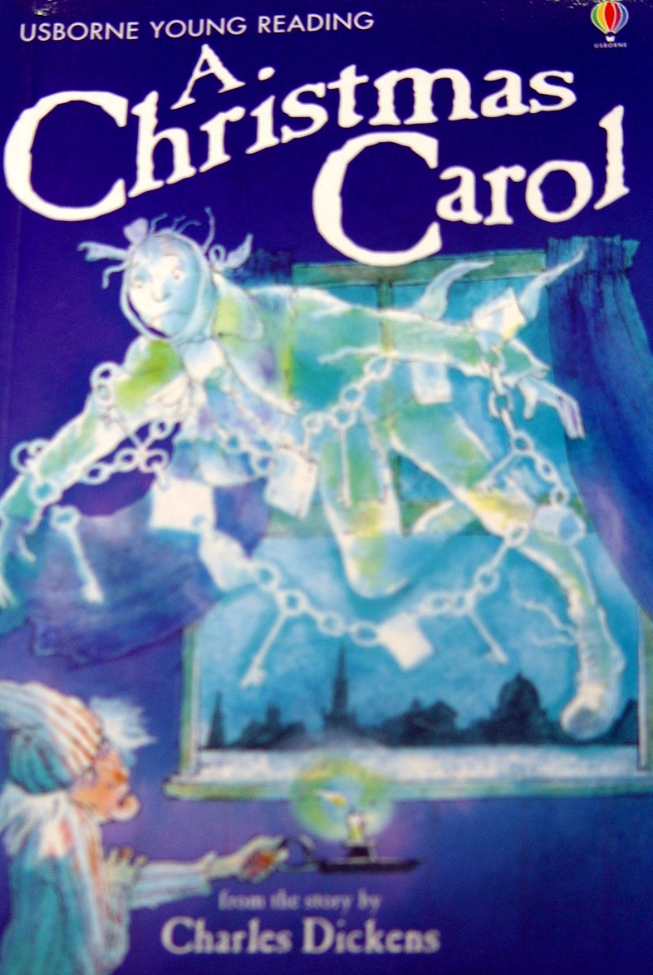
- Title: A Christmas Carol

Author: Charles Dickens
Publisher: Usborne

Library Code Number: F – DIC
Suitability: Good for everyone, especially those who love
watching the film

Have you watched the film “A Christmas Carol” before?

The film is based on a book “A Christmas Carol” written by Charles Dickens, a well-known writer. The protagonist, Scrooge, is the meanest old man you’re likely to meet. His heart is as cold as a winter’s day. However, on Christmas Eve, four ghostly visitors change his life – He finally learns what Christmas really means. Do you know why? Have a go to the library, flip through the book and you’ll know how exciting the story is!

This story book comes in two versions – a simplified version and an original version. The simplified version is easy to read as there are many attractive and colourful pictures to help understanding. So don’t hesitate! Have a go to the library and you’ll know the joy of reading it.

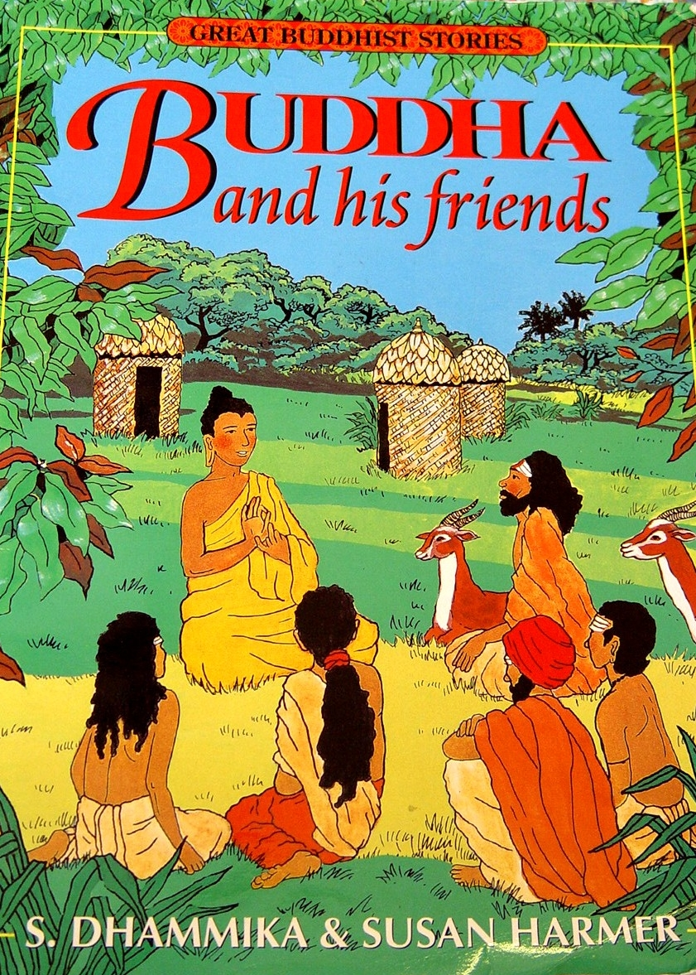

- Title: Buddha And His Friends

Author: S. Dhammika & Susan Harmer
Publisher: Times
Library Code Number: F – DHA
Suitability: Those who love comic strip

Do you like comic strip? If so, have you read the book “Journey to the West” which was recommended by Ms Ko in September? If you like the book “Journey to the West”, I’m sure you must like this book “Buddha And His Friends”.

This book is easy to read as there are many vivid and colourful illustrations. Have a look at the book in the library and you’ll know how amazing the adventure is!

