
Books Recommended by Miss Miranda Cheng

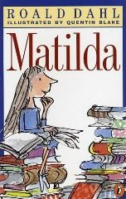
3. Title: Matilda

Author: Roald Dahl

Publisher: Puffin books
Library Code: F-DAH

“Stupid”, “ignorant”, “liar”…these are the words Matilda’s parents associate Matilda with. But the fact is that, Matilda is a genius and they are instead the stupid ones. They have even forgotten to arrange education for Matilda when she has come to the suitable age for primary school. Poor Matilda is then a bit elder then the other students when she first enters school. What’s more is that the headmistress of the school, Miss Trunchbull, is a middle-aged spiteful lady. Luckily, the class teacher of Matilda, Miss Honey, is a pleasant and gentle young lady who makes school days for Matilda enjoyable. She even discovers that there is a very special power in Matilda. Life of Matilda is then filling with challenges.

Roald Dahl is a well-known Children Literature writer. His stories are of the most pleasant for me. His choice of words is so powerful that you can visualize a picture in mind while you are reading it. I hope you can enjoy the book as much as I do!

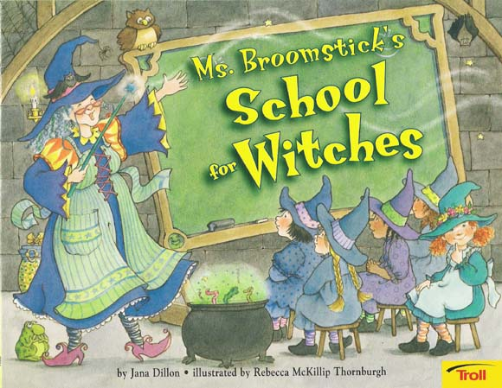
4. Title: Ms. Broomstick’s School for Witches

Author: Jana Dillon

Publisher: Hinkler Books
Library Code: F-DIL

We have different lessons and learn different things everyday. So do the witches!
In the day time, Ms Broomstick’s school is a regular school. But in the night time, after Ms Broomstick waves her wand, the school turns to a perfect place for young witches. The young witches learn to fly on a broom, pat their kittens, make witches’ brew and cast different spells in Ms Broomstick’s School for Witches.

Pandora is one of the young witches. Sometimes, for sometimes only, she is not listening to directions from Ms Broomstick carefully enough. And she has created “surprises” to Ms Broomstick and other young witches!

Enjoy your time with the young witches and find out how different a school for witches is with regular schools!

