Book Recommendation by Mr. Louis Wong

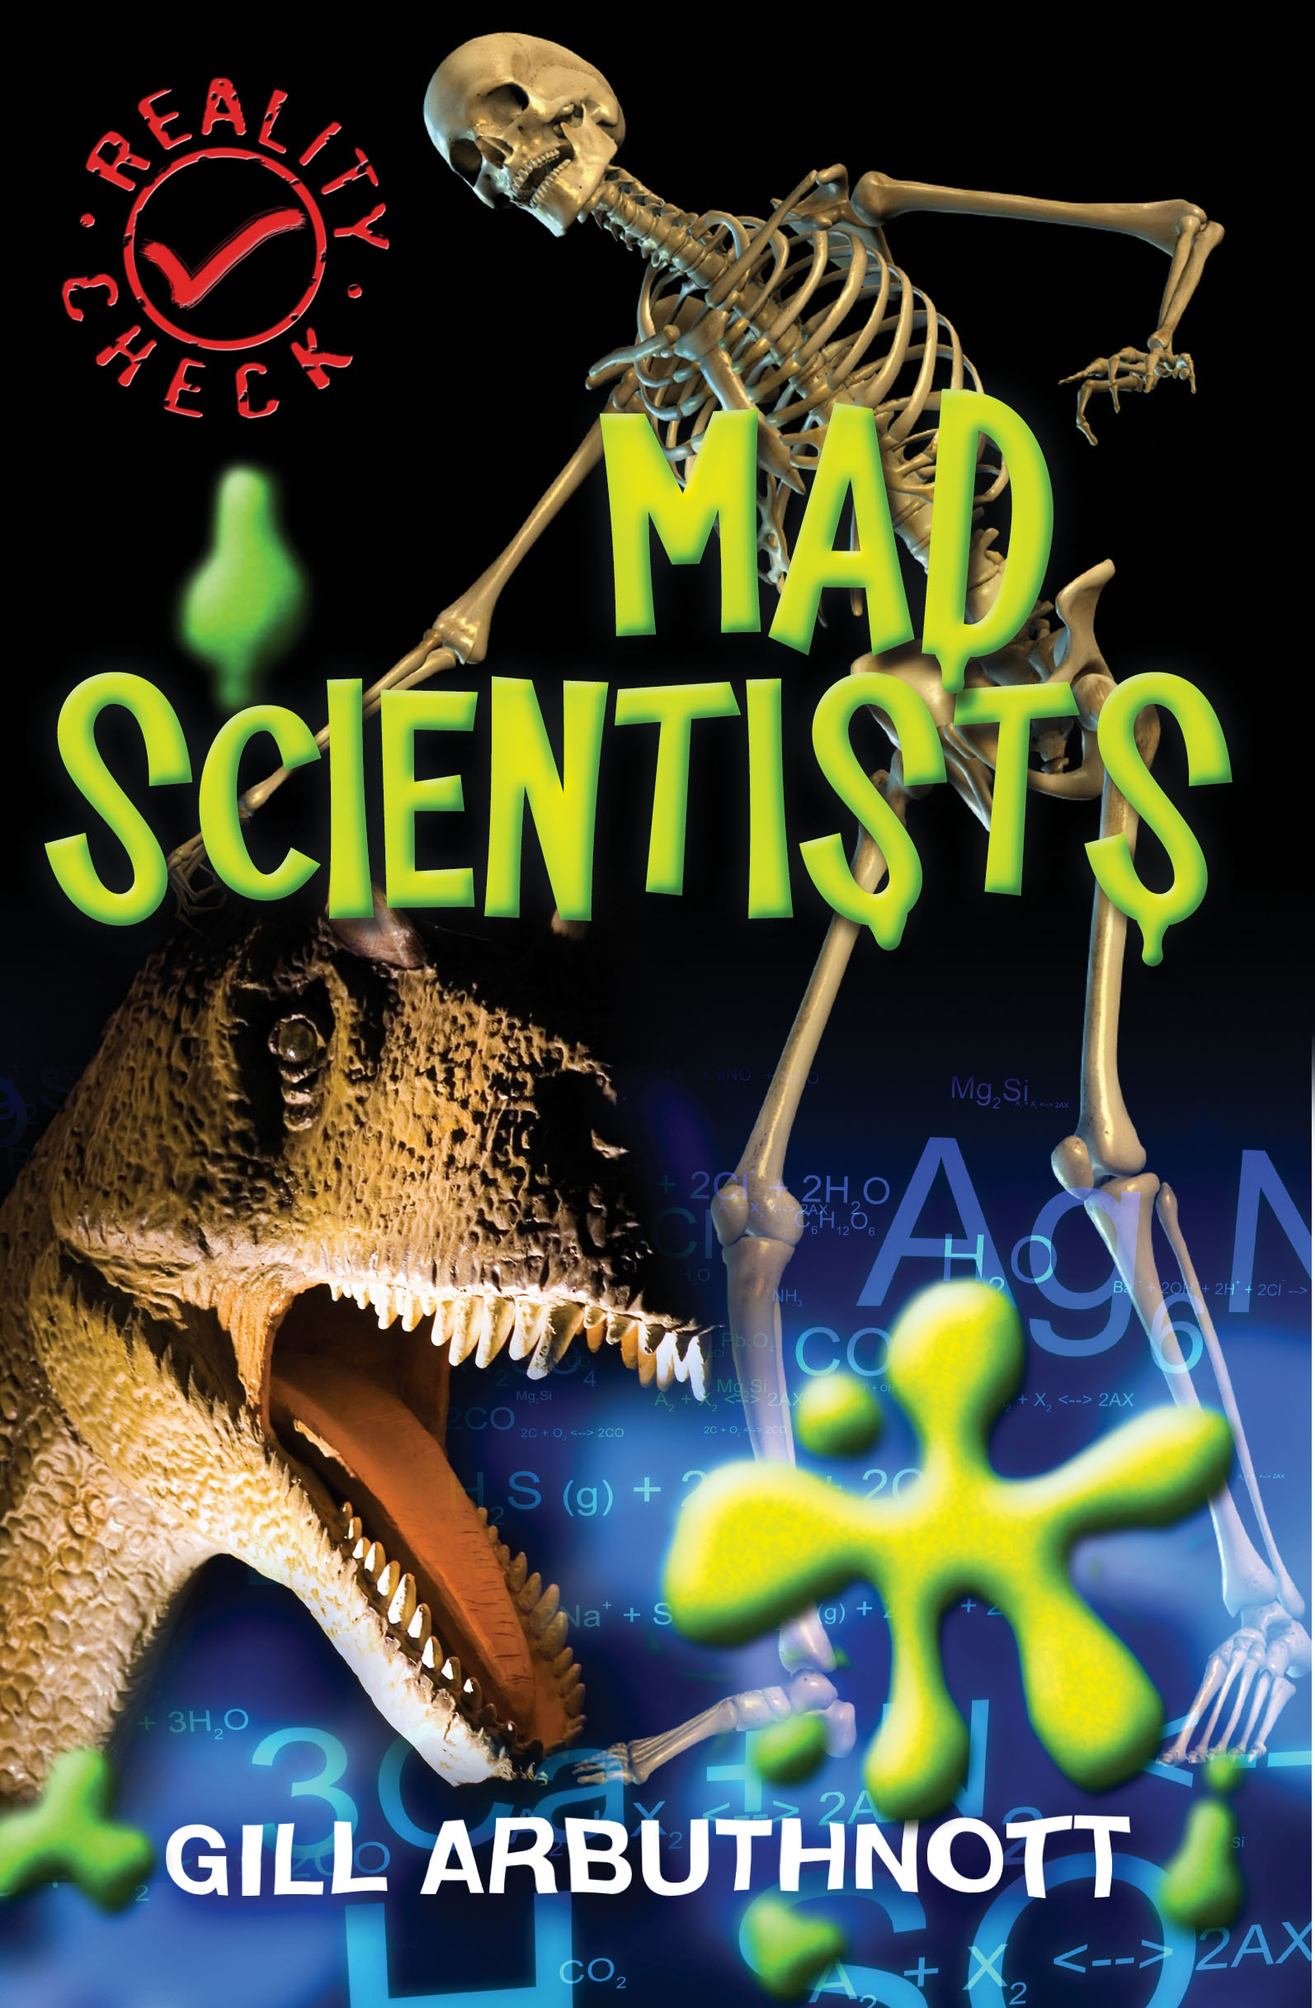
Title: Mad Scientists

Author: Gill Arbuthnott
Publisher: Barrington Stoke
ISBC: 9781842995341
Suitability: Students of Form 1 or above

Do you know…
Who's the man who ate everything?
Who's the world's most deadly inventor?
The cat that's alive and dead at the same time?
Think you know about scientists? It's time for a REALITY CHECK…
'Mad Scientists' is a hilarious but informative book at some of science's strangest ideas and thinkers, suitable for lower secondary students.

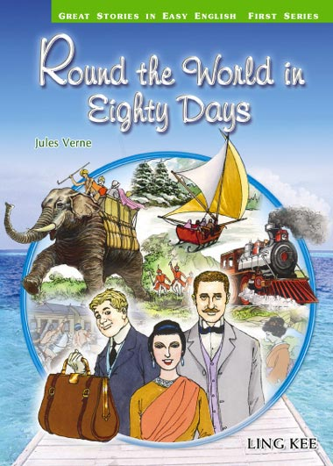
Title: Round the World in Eighty Days
Author: Jules Verne
Publisher: Ling Kee Publishing Ltd.
ISBC: 9626083441
Suitability: Form 1 or above

Phileas Fogg, an English gentleman, claims that he can go round the world in eighty days. If he does not succeed, he will lose twenty thousand pounds. He meets all kinds of difficulties and dangers in his journey. He has travelled by ship, train, elephant and even by sledge. In the end, however, he manages to reach home in time to win his bet.

