Book Recommendation by Mr. James Chu

Title: The Little Prince

Author: Antoine de Sanit-Exupery
Publisher: A Harvest Book

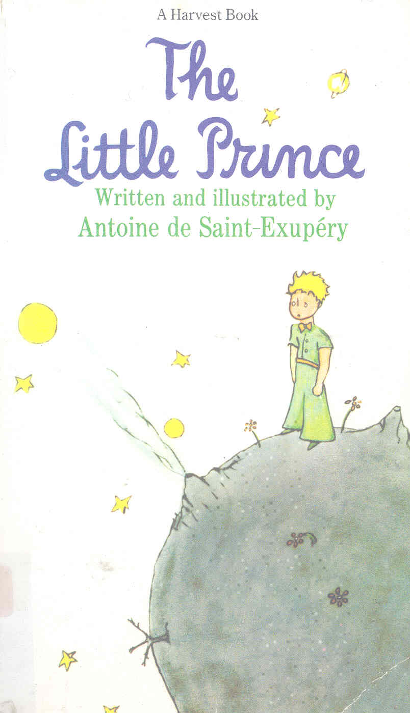
Library Code Number: F – SAI
Suitability: Suitable for everyone

The Little Prince makes several profound and idealistic points about life and human nature. Saint Exupery tells of meeting a young, though entirely human appearing, prince in the middle of the Sahara. The essence of the book is contained in the famous line uttered by the fox to the Little Prince: "One cannot see well except with the heart, the essential is invisible to the eyes." There are also two other main points in the book, both spoken by the fox. They are: "You become responsible, forever, for what you have tamed" and "It is the time you have spent with your rose that makes your rose so important." I like these kinds of conversation. It is really wonderful. Also, I admired that the Little Prince lived alone on a tiny planet no larger than a house. He owned three volcanoes, two active and one extinct. He also owned a flower which is unlike others. This can give him pride. This is a very good and interesting story. If you want to know more about him, you can

go to the library to borrow it.

Title: Gulliver’s Travels

Author: Jonathan Swift
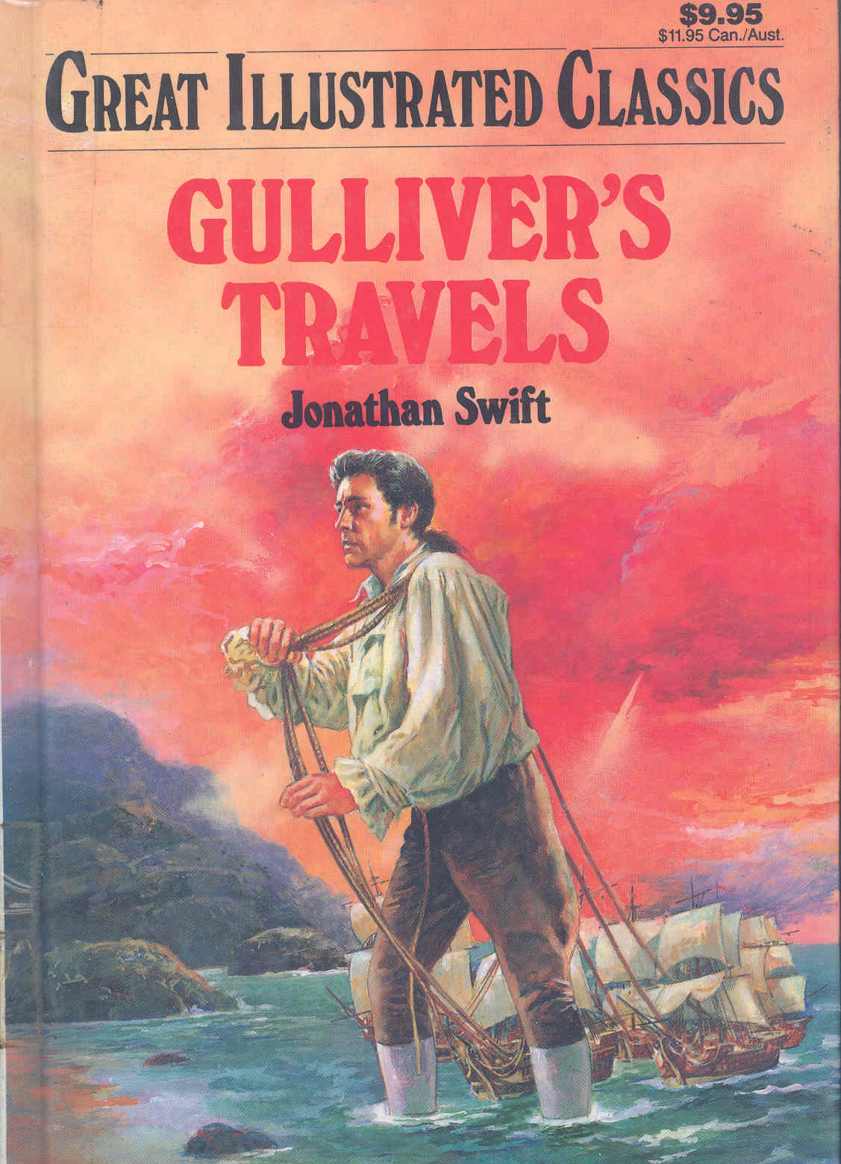
Publisher: Baronet Books Company, New York

Library Code Number: F – SWI
Suitability: Suitable for everyone
Gullivers Travels presents itself as a simple traveler's narrative written in simple English. It suits everybody who likes reading books. The hero “Lemuel Gulliver” first is a surgeon, then becomes a captain of several ships". The book is told by dividing into four parts which firstly begins with a short preamble in which Gulliver, gives a brief outline of his life and history prior to his voyages. He enjoys traveling. This turns out to be fortunate.
On his first voyage, Gulliver is washed ashore after a shipwreck. Then, the book follows Gulliver's observations on the Court of Lilliput, which is intended to satirize the court of George I. With the assistance of a kind friend, Gulliver escapes to Blefuscu, where he spots and retrieves an abandoned boat and sails out to be rescued by a passing ship which takes him back home. The feuding between the Lilliputians and the Blefuscudians is meant to represent the feuding countries of England and France, but the reason for the war is meant to satirize the feud between Catholics and Protestants. Fights between them happened often afterwards. The story is amazing and attractive if you like reading story of adventure. I highly recommend it to all of you.

