Book Recommendation by Mr. Tsang

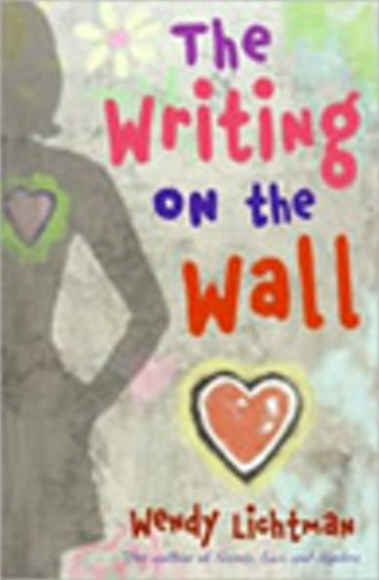
Title: The Writing on the Wall
Author: Wendy Lichtman
Publisher: Harper Collins
ISBN: 978-0061229589
Suitability: S.4-S.5

I like reading storybooks, which can enrich my vocabulary and the sense about the language I am teaching, i.e. English. In addition, it is a good pastime. I would like to recommend our S.4 to S.5 students reading this fiction, which is a sequel to the novel, ‘Do the Math: Secrets, Lies, and Algebra’. It belongs to the genre of mysterious fictions, which many young people like. In addition, the story is about school life which makes it familiar to you.
In this story, the main character, Tess and her friends are back in school from winter break. The second term is not off to a good start. There is a mysterious fire in the computer room the first week back. Richard, who is Tess’s enemy, continues to bully her. His tricks on Tess and her friends, such as tearing pages from her English journal and stealing her backpack are not only annoying, but making her look like a slacker to her teachers.
It seems the only good thing in Tess’s school life is algebra class—a subject she loves most. Algebra is logical, it makes sense. One can find solutions by looking for patterns and using formulas. Indeed, Math is not only Tess’s favourite subject but it has also become Tess’s spiritual support.
Tess has found some mathematical formulas and questions showing up on the wall of the church behind her school. She is obsessed with solving the questions. With the help of her grandfather, she realizes the person who has written the mathematical stuff on the wall. ‘Could this somehow be related to the computer lab fire?’ she thinks. Tess decides to communicate with that person.
What do you think will happen to Tess in her search for the answer to the mystery? Let’s read the book to find out. I highly recommend this fiction to students who like science and books of mysterious genre.

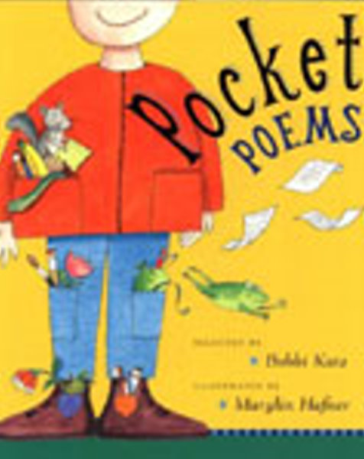
Title: Pocket Poems
Selected by Bobbi Katz
Illustrator: Marylin Hafner
Publisher: Penguin
ISBN: 0525471723
Suitability: S.1-S.3

Seeing English movies is a good way to learn the English culture, reading poems is no exception. The latter is especially good for S.3 students, who are going to take their TSA exams, in which they need to comprehend poems. It is an anthology of short poems that are written by some secondary school students at your age and their English teacher after reading some pock-sized poems.
I find the poems perfect for introducing children to the world of poetry. Clearly, the collector and editor of this anthology have done a superb job- some selections are a mixture of silly and serious, fun and fantastical, thoughtful and nonsensical masterpieces. In addition, the poems are illustrated fascinatingly. Many of the illustrations are done in pen-and-ink and watercolor. They are full of details that capture perfectly the imagery of the text.
In spite of its small size, it contains more than fifty poems, most of which just cost you a couple of minutes to read.

Again, I strongly recommend you reading the anthology and better buying one.

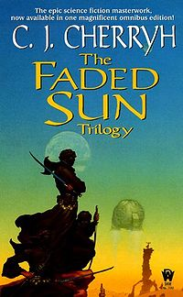
Title: The Faded Sun
Author: C.J. Cherryh
Publisher: Mandarin
ISBN 0886778697
Suitability: S.4-S.7

When I was a secondary school student, I was an addict of Chinese science fictions, especially those written by the renowned writer, Mr. Wisely, Ngai Hong. Speak the truth, I found reading English science fictions too difficult for me before I entered the University, in which English science fictions had ‘suddenly’ become my favourites. Thanks to my university coursemate, who made me frenzy about that kind of novels.

The book was originally published in three volumes about a decade ago, The Faded Sun is one of the author’s earliest science fiction works, and is characteristic of her output. It is a novel about an alien species called, the mri, and their interactions with man and with another species called, the regul. The plot involves a human joining two mri and helping them to save their species.
I find that storylines about alien species are among the most popular themes of science fictions. I think it is because alien things such as ET and UFO can arouse the curiosity of people especially the youngsters. The interactions between humans and the aliens depicted in the Faded Sun can surely arouse your interest in flipping the book page by page!

