Book Recommended by Ms. Elizabeth Lee

Title: Positive Thinking
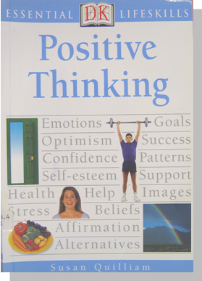
Author: Susan Quilliam
Publisher: Dorling Kindersley Limited
Library Code: 153.4 QUI
Suitability: Good for everyone, especially those who want
to think more positively

Have you ever felt you are depressed? Have you ever feel you are under great pressure? Have you ever had problems in human relationship?

If yes, then this book Positive Thinking just suits your needs!

As a one living in this hectic world, it is very important for us to adjust ourselves and maintain healthy conditions in both psychological and physical aspects. This book suggests numerous ways of staying positively, e.g. how to be confident, maintain good human relationship, manage stress and set goals and values. More importantly, there are some tips, i.e. ‘Things to do’ and ‘Things to avoid’, reminding us the ways of having positive thinking.

Having positive thinking is crucial to our personal development. Why not go to the library to have a look at the book?

