Book Recommendation by Miss Christy Cheng

Title: Daddy-Long-Legs

Author: Jean Webster
Publisher: Puffin Books
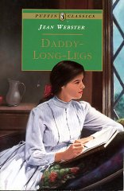
Library code: E01938
Suitability: Students of Form 3 or above

This is a famous tale of an orphan who writes to her trustee regularly. The book contains a collection of letters, both long and short. The letters are light-hearted and expressive. You cannot resist flipping one after another. If you want to learn how to write informal letters, you can find good examples from this book!

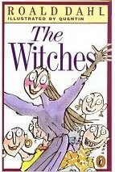
Title: The Witches
Author: Roald Dahl
Publisher: Puffin
Library code: E01940
Suitability: Form 3 or above

If you walk into bookshops, it is not difficult to find a collection of books written by Roald Dahl. The Witches is definitely one of the best. Roald has been famous for his creativity. Everything unimaginable can happen. The story tells you that witches are everywhere. Just turn round and you may find that one of your friends is a witch too! Want to protect yourself from the witches’ spells, you must read the book to find out where the witches are.

