Book Recommendation by Ms. Brenda Chan
Title: Simpsons Comics A go-go  Author: Matt Groening  Publisher: Harper Collins  Library Code: F GRO  Suitability: Both junior and senior formers | 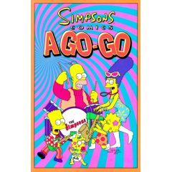
Do you like The Simpsons? Have you ever watched the cartoons of
The Simpsons on TV? If you do, you must like this book! This book
contains 8 stories which are so funny that you can't stop laughing.
The pictures are very colourful and the characters are cute.
They help you understand the stories well.

Title: Charlie and the Chocolate Factory  Author: Roald Dahl  Publisher: Puffin  Library Code: F DAH  Suitability: Both junior and senior formers | 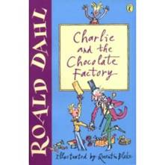

Mr Wonka's inventions are out of this world. He has thought up
every kind of sweet imaginable in his amazing chocolate factory,
but no one has ever been inside, or met Mr Wonka! Charlie Bucker
can't believe his luck when he finds a golden ticket and wins the
trip of a lifetime around the famous chocolate factory. He still could
never have dreamed what surprises lie in store! This book is
especially suitable for chocolate lovers!

